Homework Assignment 02

Name: Asrar Syed
Due by: September 24, 2025
Course Section: CSC 4222-008

PART A – User Authentication (30 points)

- List and briefly explain any four password vulnerabilities. (4 pts)

  - Predictable passwords: users select obvious combinations such as “password” or “qwerty.”
  - Repeated credentials: using identical login details on multiple platforms puts all accounts with the same password at risk if one is compromised.
  - Exchanging passwords: sharing login info with others or jotting it down insecurely.
  - Simple composition: passwords lacking variety in letters, numbers, or symbols are more susceptible to guessing attacks.

- Briefly explain the difference between dictionary attacks, rainbow table attacks, and password cracking attacks. (6 pts)

  - Dictionary attack: The attacker tries passwords from a pre-made list of common words, phrases, or easy patterns. For example, “password123” or “sunshine.”

  - Rainbow table attack: The attacker uses a table of precomputed password hashes. Instead of recalculating the hash each time, they can look it up and find the original password quickly.

  - Password cracking: This is a broader method that tries every possible combination or uses mixed strategies until the correct password is discovered. It can include brute force, dictionary attacks, and other techniques.

- Why does adding a salt to password hashing improve security? (5 pts)

Adding a salt makes each password one of a kind, even if two people pick the same password. We can think of the salt as a extra random value mixed in before turning the password into a hash. That way, someone trying to crack passwords can’t just use a pre-made list or reuse one cracked password on other accounts. They have to work on each password separately, which takes a lot more time and effort.

Practical Exercise (Coding) – Password hashing & salting (15 points)

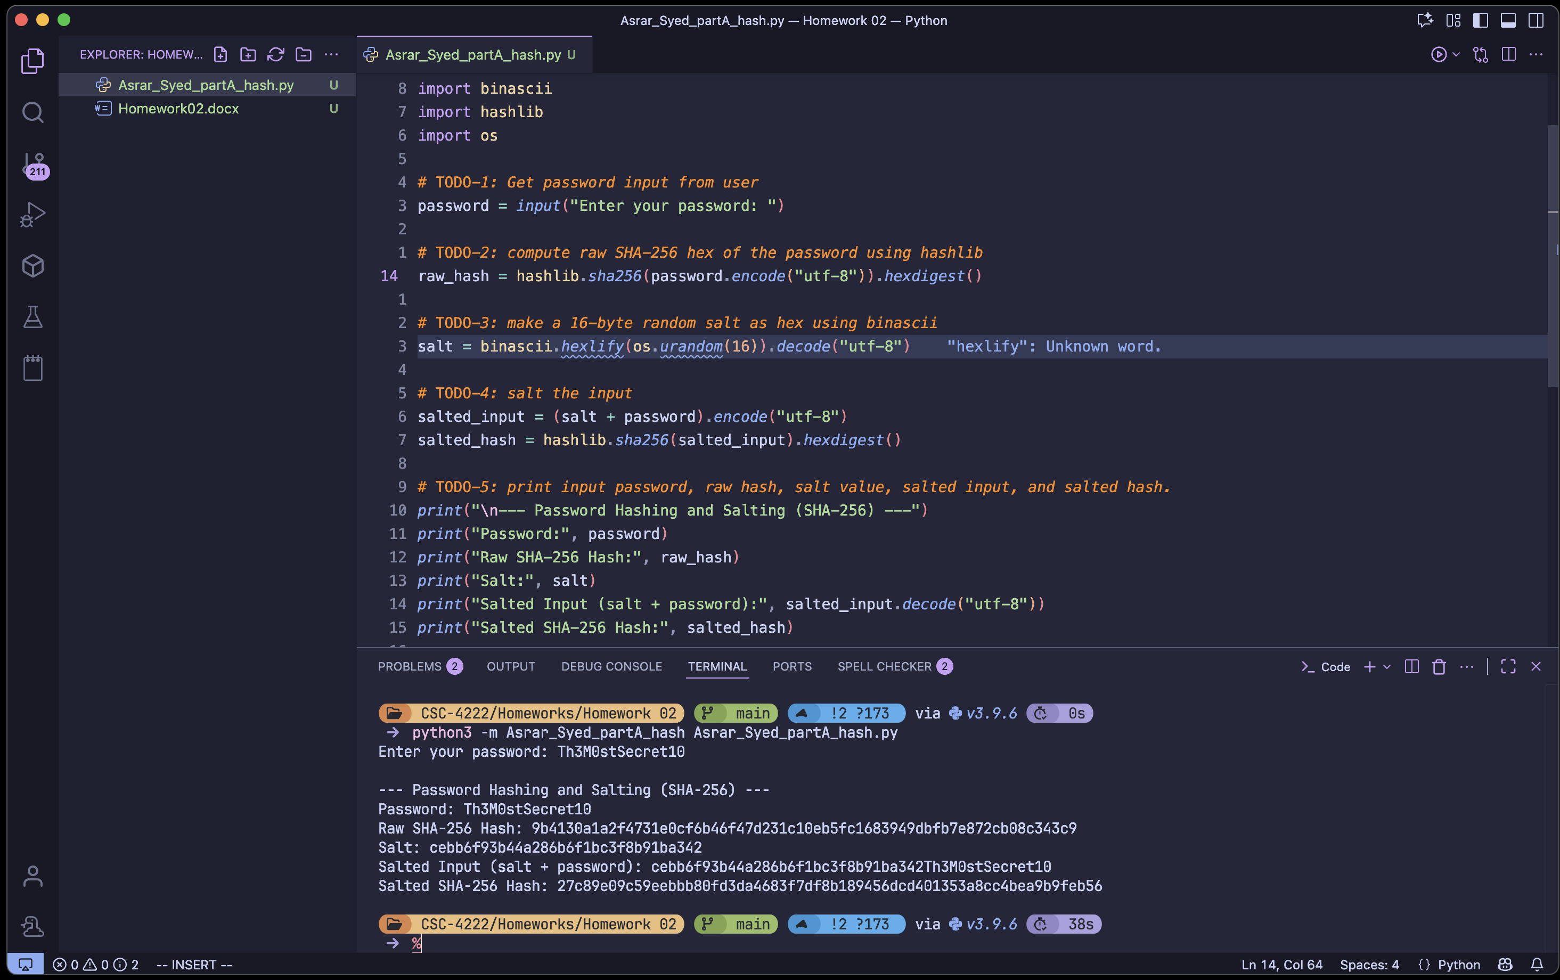

PART B – Password Security (40 points)

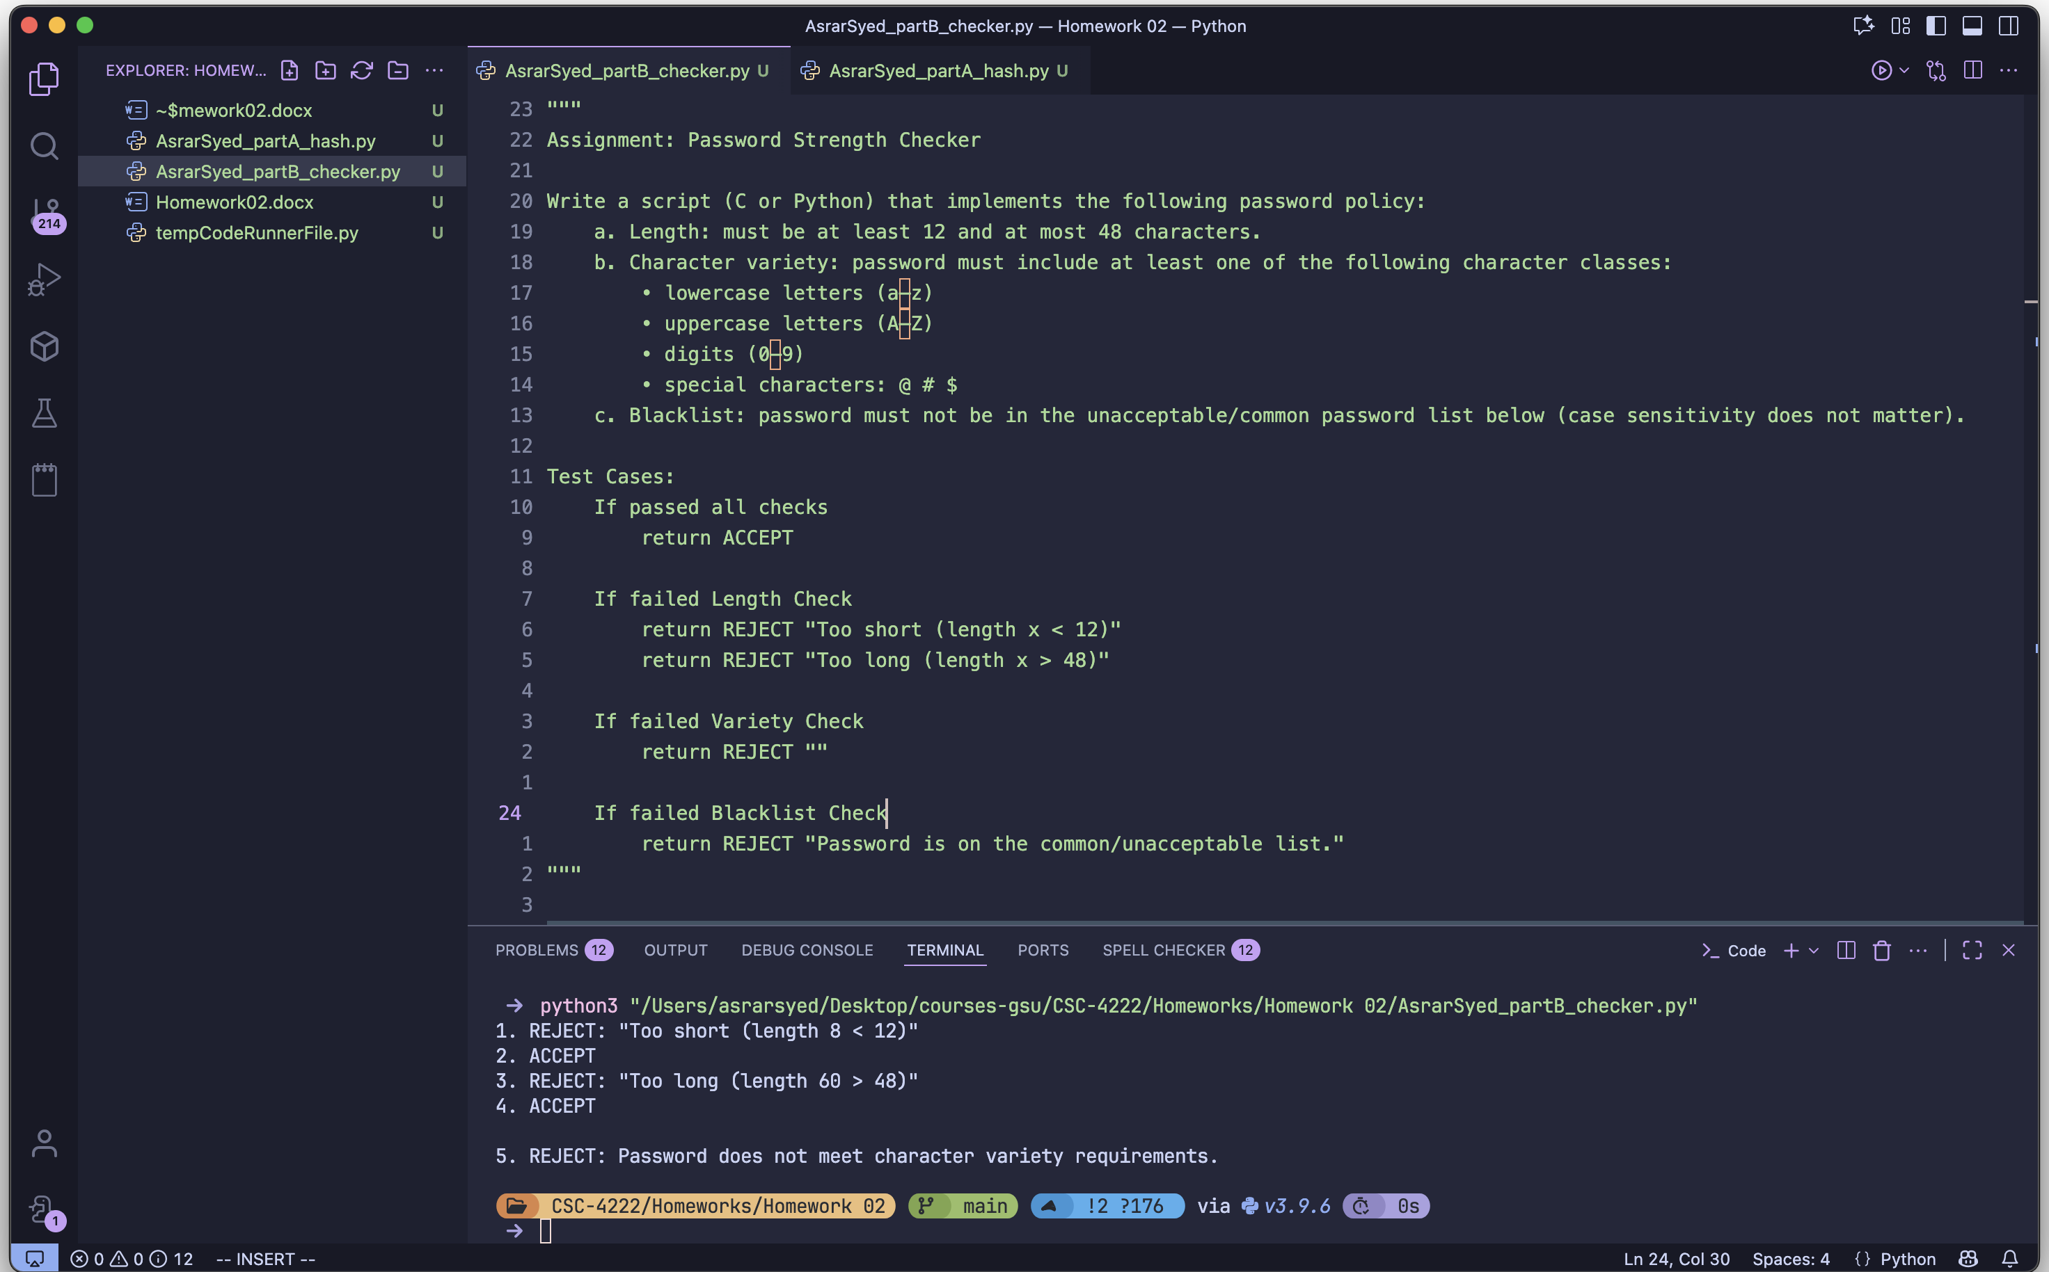

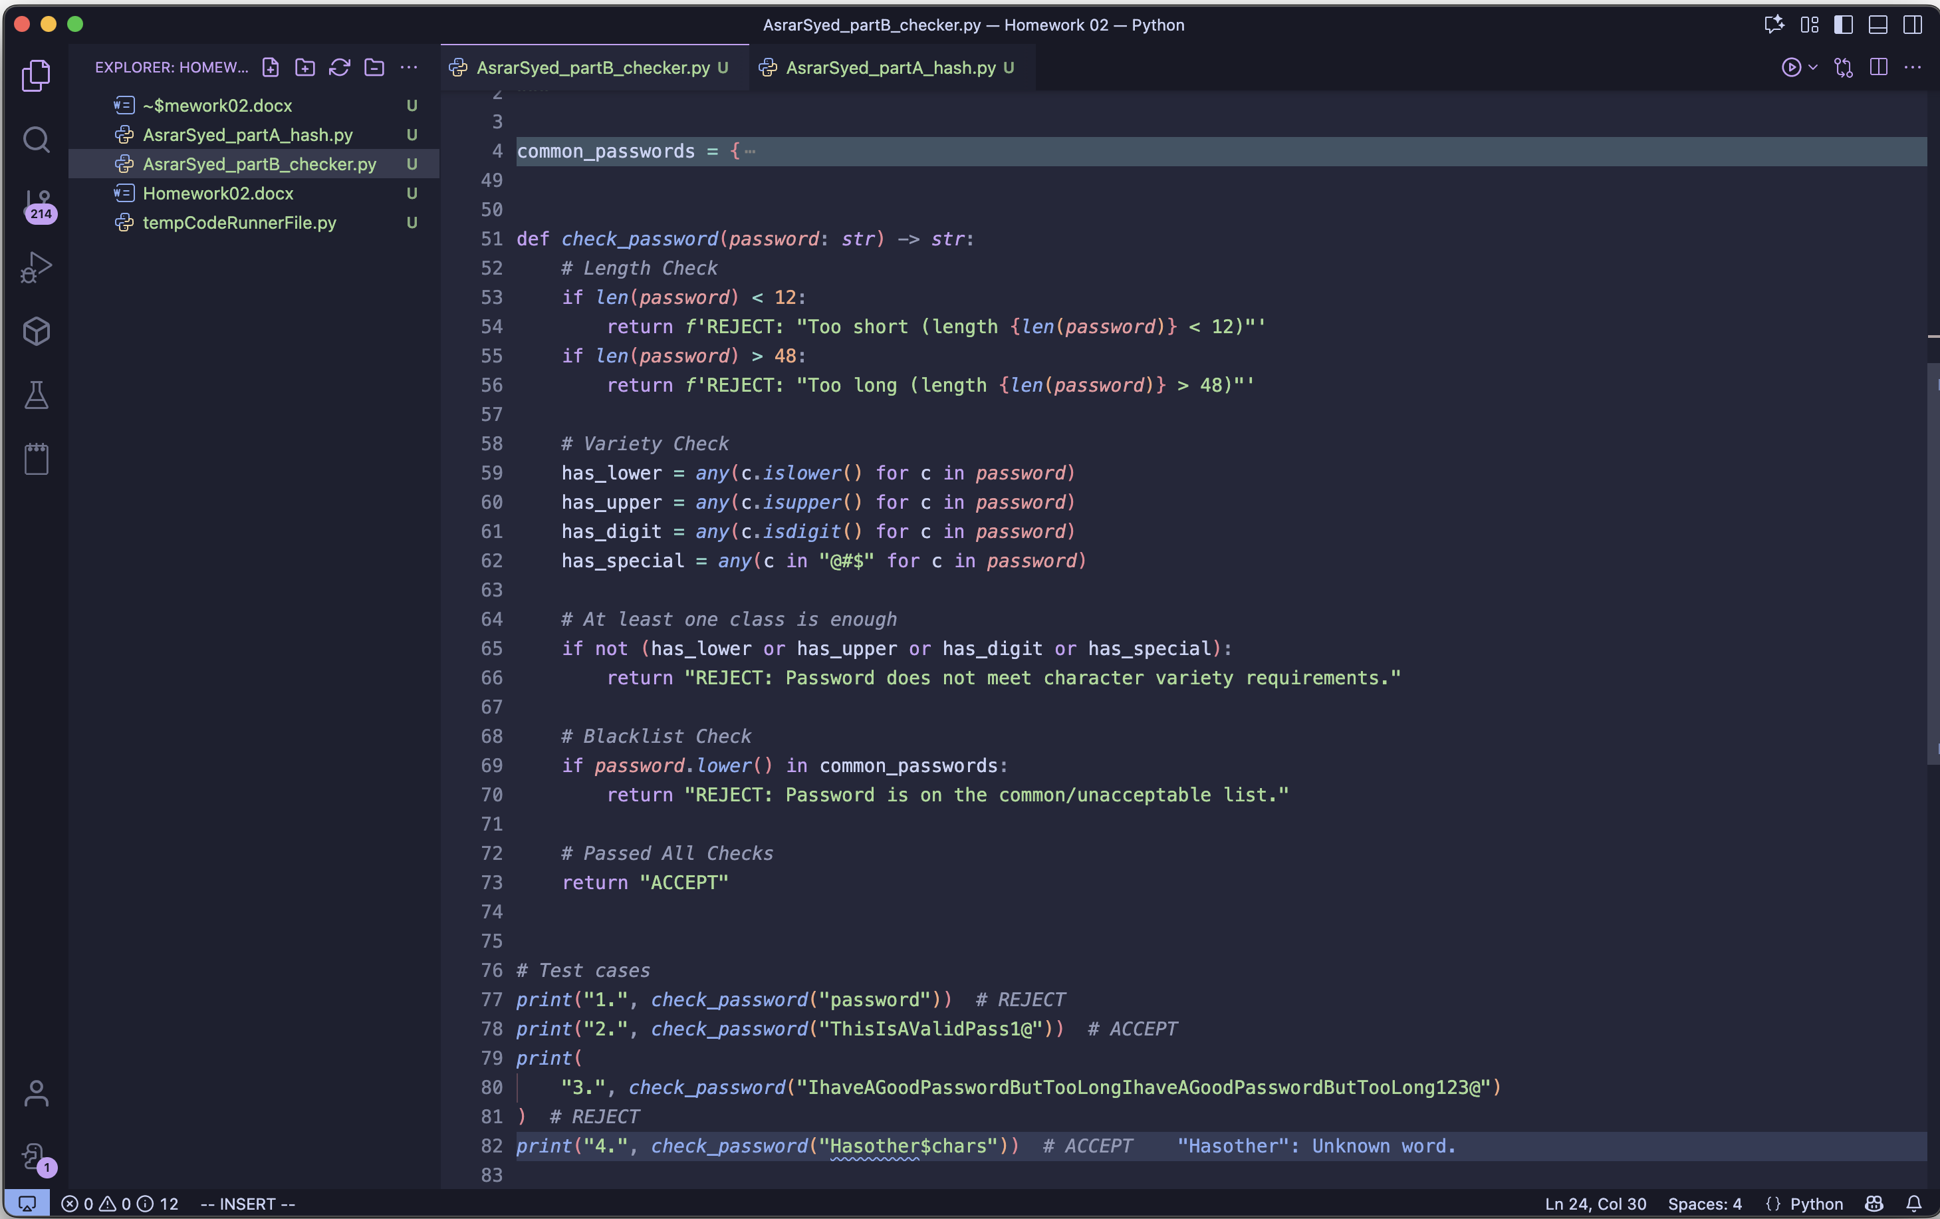

PART C – Buffer Overflow (30 points)

- Briefly define a buffer and explain the difference between stack, heap, and global buffers. (6 pts)

A buffer is a block of memory used to hold temporary data such as strings or arrays.

  - Stack buffer: lives in a function’s stack frame, created automatically for local variables, and disappears when the function returns.
  - Heap buffer: created dynamically with calls like malloc or new, persists until explicitly freed.
  - Global buffer: fixed-size allocated in the global data region, and exists for the entire lifetime of the program.

- Explain how a buffer overflow can be used to overwrite a return address. (5 pts)

When a local buffer on the stack is too small for the copied input, extra data spills past its boundary. The overflow continues into nearby memory, eventually reaching the saved return address. If overwritten, the processor will load this corrupted address during the function return, redirecting execution to an attacker’s chosen location.

- List any two compile-time defenses and any two run-time defenses against buffer overflow. (4 pts)

Compile-time Defenses:

  - Stack canaries
  - Bound checking

Run-time Defenses:

- Address Space Layout Randomization (ASLR)
- Data Execution Prevention (DEP)

Practical Exercise (Coding in C) (15 points)

